**Linkage of FRESH:COM to the openENTRANCE Platform (17.11.2020)**

Still missing: unit conversion that’s in line with nomenclature

Code and data available at: <https://github.com/tperger/FRESH-COM>

Showing screenshots of the successful linkages of FRESH:COM:

1. Load data from GENeSYS-MOD from IIASA scenario explorer:

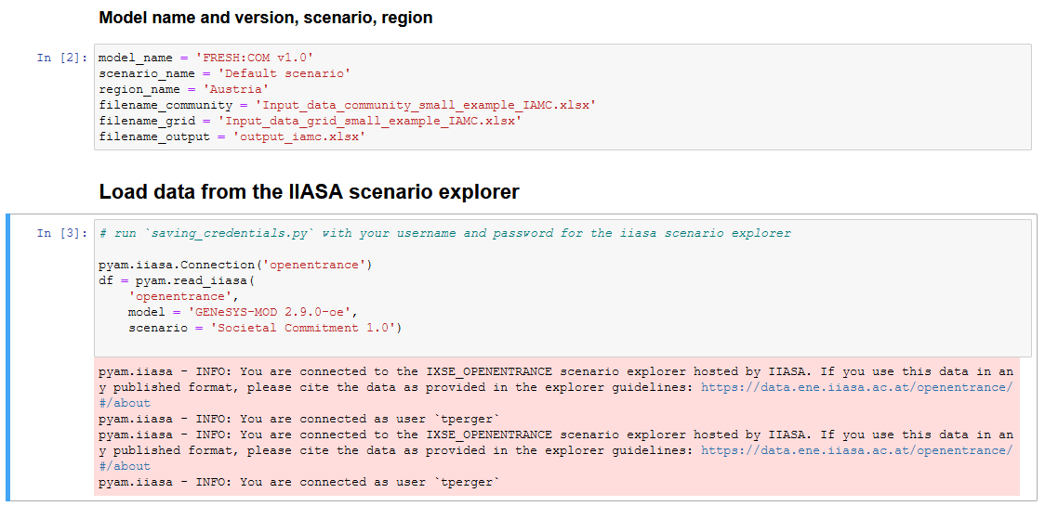

And save as *pandas* for further data processing within the model:

*df.as_pandas()*

1. Own data (from FRESH:COM) can also be downloaded to the program:

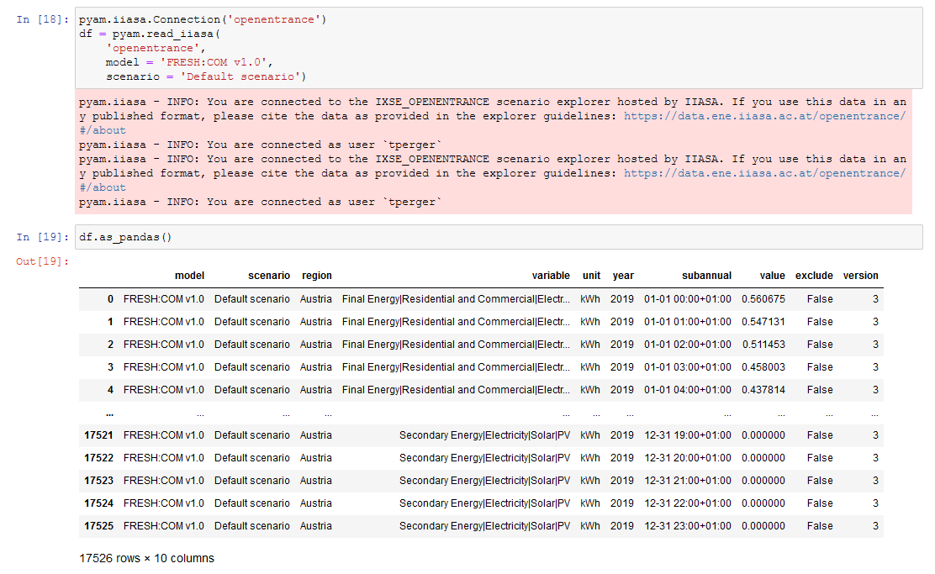

1. Validating the input files:

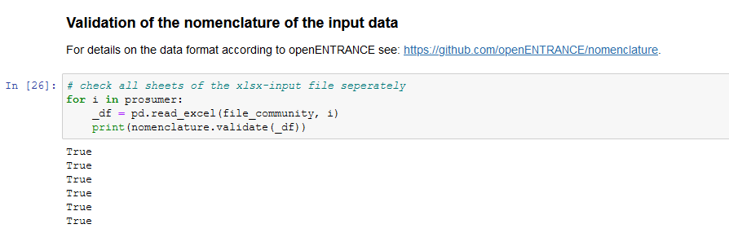

1. Writing output to IAMC format and save as excel file:
   1. Use a function to create a *pandas.DataFrame* with the same structure as *pyam.IamDataFrame*

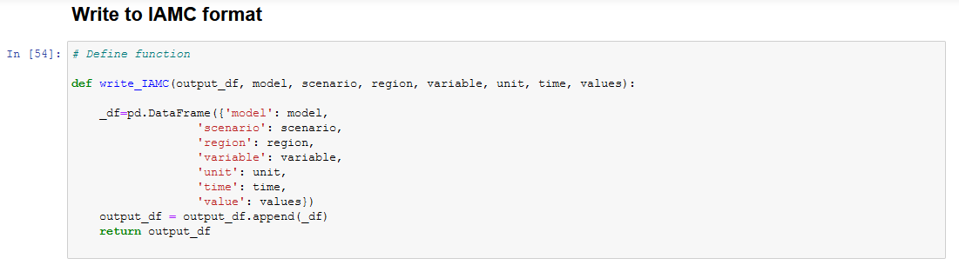

* 1. Write to excel

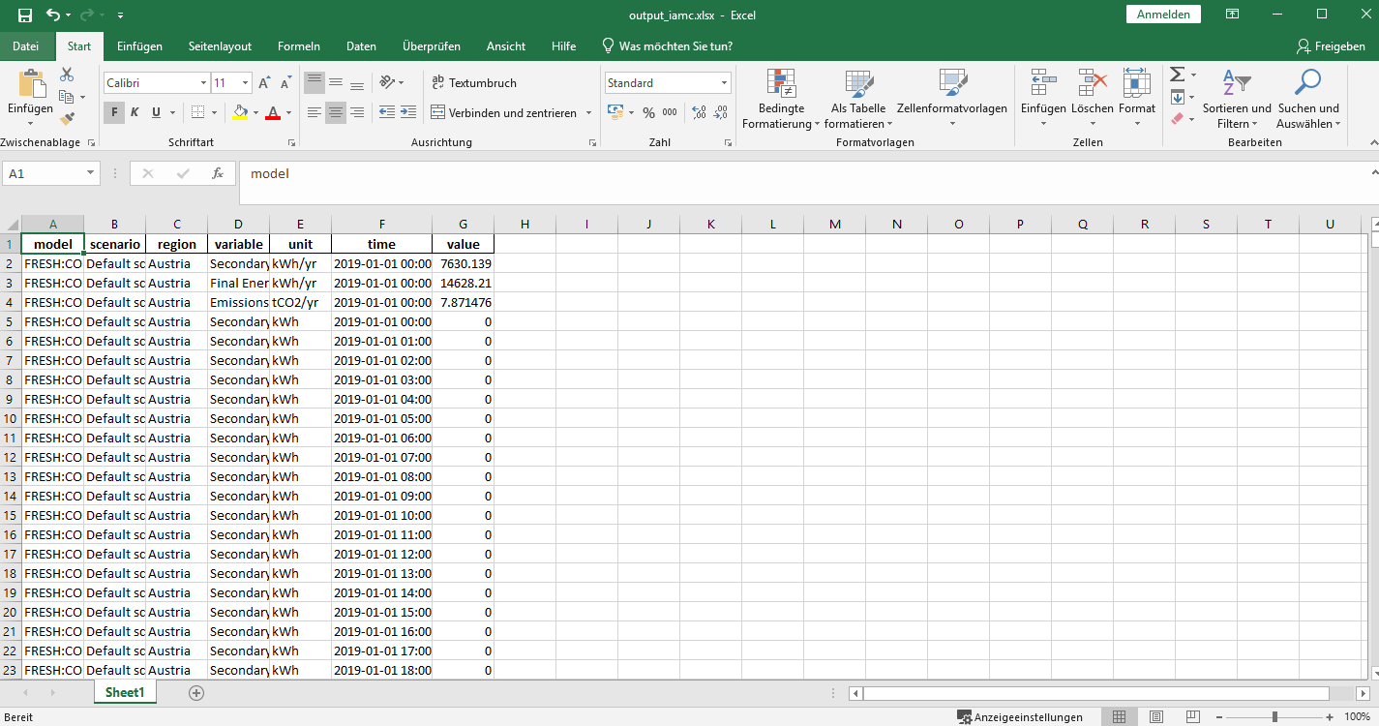

* 1. Upload to the scenario explorer:

